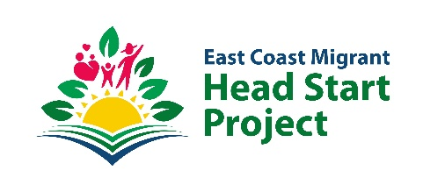

East Coast Migrant Head Start Project recognizes the Service and Leadership
of six trailblazers in Texas
- ECMHSP leads the way in creating pipelines for early childhood education and offers paid internship opportunities to current South Texas College undergraduate and graduate students. The program features hands-on experience in ECMHSP campuses across ten states.
Texas, U.S. January 13th, 2023.- East Coast Migrant Head Start Project (ECMHSP), a non-profit organization with more than fourteen years of serving farmworker families, is pleased to recognize the service and leadership of six trailblazers in Texas. These recognitions align with ECMHSP’s strategy of providing visibility and support to the organizations, businesses, and community leaders that promote the educational advancement, economic mobility, and well-being of families and communities.
“Having leaders and allies to help us in our mission to prepare the children of seasonal and migrant farmworkers for success is one of our priorities,” said Maria C. Garza, Chief Executive Officer of East Coast Migrant Head Start Project, who presented the awards to the following leaders:
PhD Carmen Valle, Vice president of Child Development, UMOS
Mrs. Rose Benavides, Chair STC Board of Trustees
Mr. Josh Mejia, President & Chief Executive Officer of the McAllen Chamber of Commerce
Hon. Vicente Gonzalez, Congressman (TX-34 Congressional District)
Hon. Henry Cuellar, Congressman (TX-28 Congressional District)
Hon. Monica De La Cruz, Congresswoman (TX-15 Congressional District)
During her visit to Texas, Maria C. Garza celebrated East Coast Migrant Head Start Project's commitment to strategic partnerships in support of early childhood as denoted by the signing of the Memorandum Of Understanding (MOU), between ECMHSP and South Texas College. "With this strategic collaboration, we are opening the door to outstanding students who want to further their education with hands-on, cross-functional, professional experience with one of the leading educational organizations in early childhood."
Aurora Torres, a South Texas College Student in early childhood education who received a paid internship from ECMHSP, shared her experiences: “East Coast Migrant Head Start Project has allowed me to grow as an employee, student, and person. Working and studying simultaneously gave me insights into the work and made my career path easier. I love talking about my work because many of the things you see in your classes, you can practice in the work field. I now motivate others to seek these opportunities to learn and grow.” The paid internship opportunity also granted Aurora college course credit and the option to leverage a comprehensive transfer package to work in ECMHSP campuses while connecting virtually with South Texas College instructors.
East Coast Migrant Head Start Project, (ECMHSP) was established in 1974 through a grant from the United States Department of Health and Human Services. Currently, ECMHSP operates in 42 direct Educational Campuses and 6 delegates across ten states providing holistic, high-quality early childhood education services for approximately three thousand farmworker children between six weeks to six years old.
Media contact ECMHSP: Berenice Malagon, Director of Communication, bmalagon@ecmhsp.org or (984) 275 7577.

